HCI Coursework 1 Submission 1

The application I have chosen to design is a cross platform video game tracking app. This app will allow users to log their progress in games across multiple platforms (primarily Playstation, Xbox and PC) and compare and contrast their progress against their friends, as well as issuing challenges to friends to match achievements or beat high scores. The app will also feature user generated game reviews and ratings and will feature a new release and coming soon page where users can say which games they are most anticipating and generate interest for new games.

A typical persona that would use this kind of app would be an avid gamer. Most games are available for multiple platforms and it is very unusual for a person to buy the same game for more than one of these platforms. This persons friends may not have the game on the same platform as them and it is difficult to track progress against each other. Using this app will allow the user to be competitive against their friends in a way that the consoles alone will not allow, it will also allow them to send their friends game related messages which is not possible between platforms and to share and issue challenges without using other forms of social media. They can then also view what other games their friends like and see reviews for said games which may help them make a decision about buying it for themselves. Another use of the app would be for the user to browse through newly released and upcoming games and share this information easily with their friends again without resorting to other forms of social media.

Use Case Example

Use Case: User updates game progress

Precondition: Registered user

Basic Flow

1. User opens application
2. User navigates to their chosen game
3. User accesses achievement list
4. User checks box for any completed challenges
5. User saves changes
6. User exits application

Alternative Flow

2i. User adds new game

2ii. User starts typing and selects game from list

2iii. Game is added to list, in game achievements added automatically

5i. User compares challenges to friends

5ii. User messages friend to issue a challenge

5iii. User is notified if challenge is accepted or declined

State Transition Networks

Basic Flow

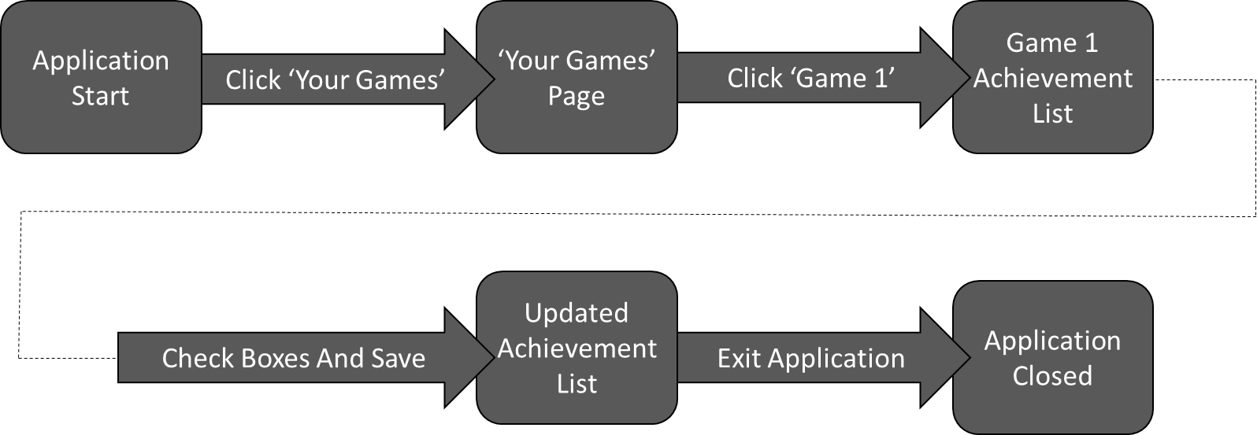

Alternate Flow 1

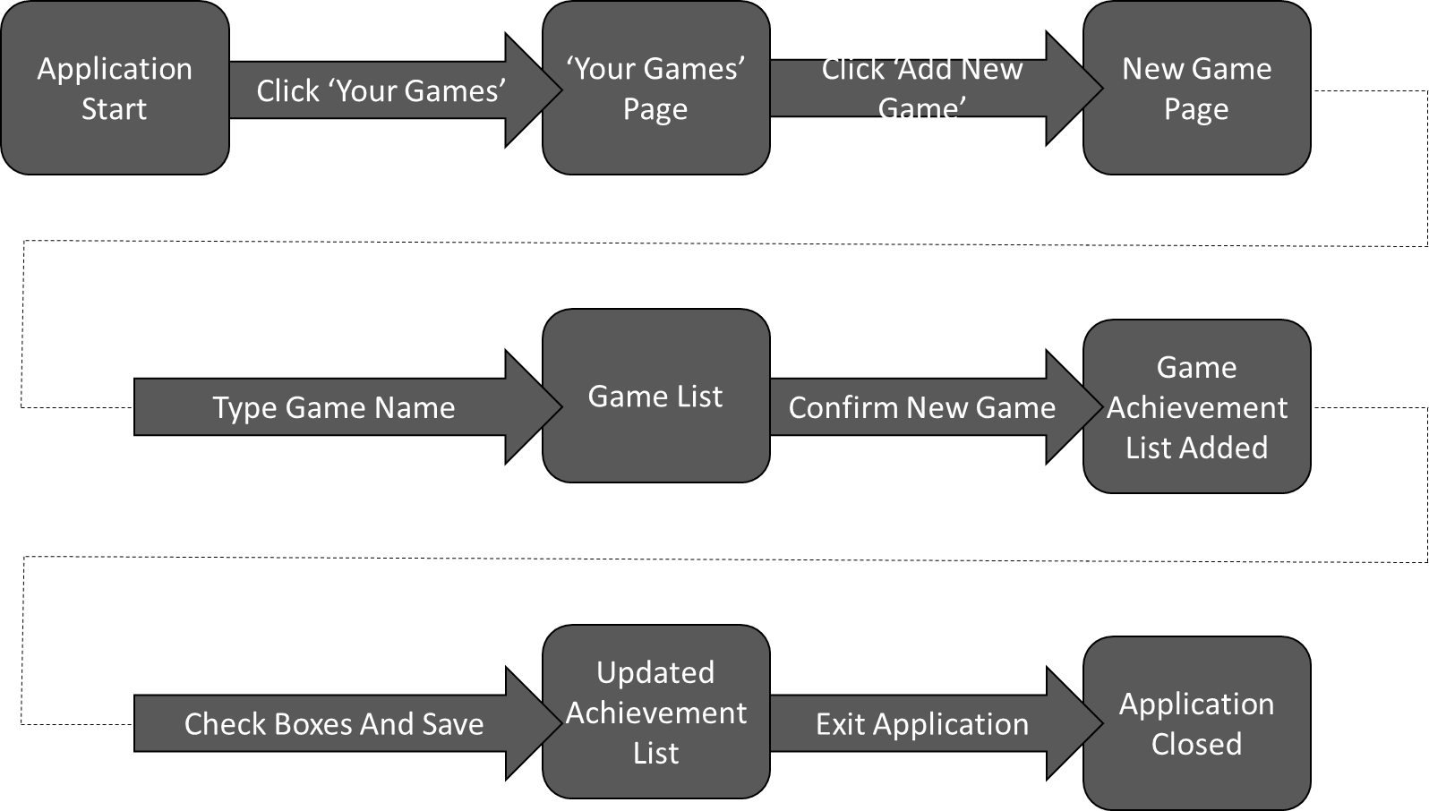

Alternate Flow 2

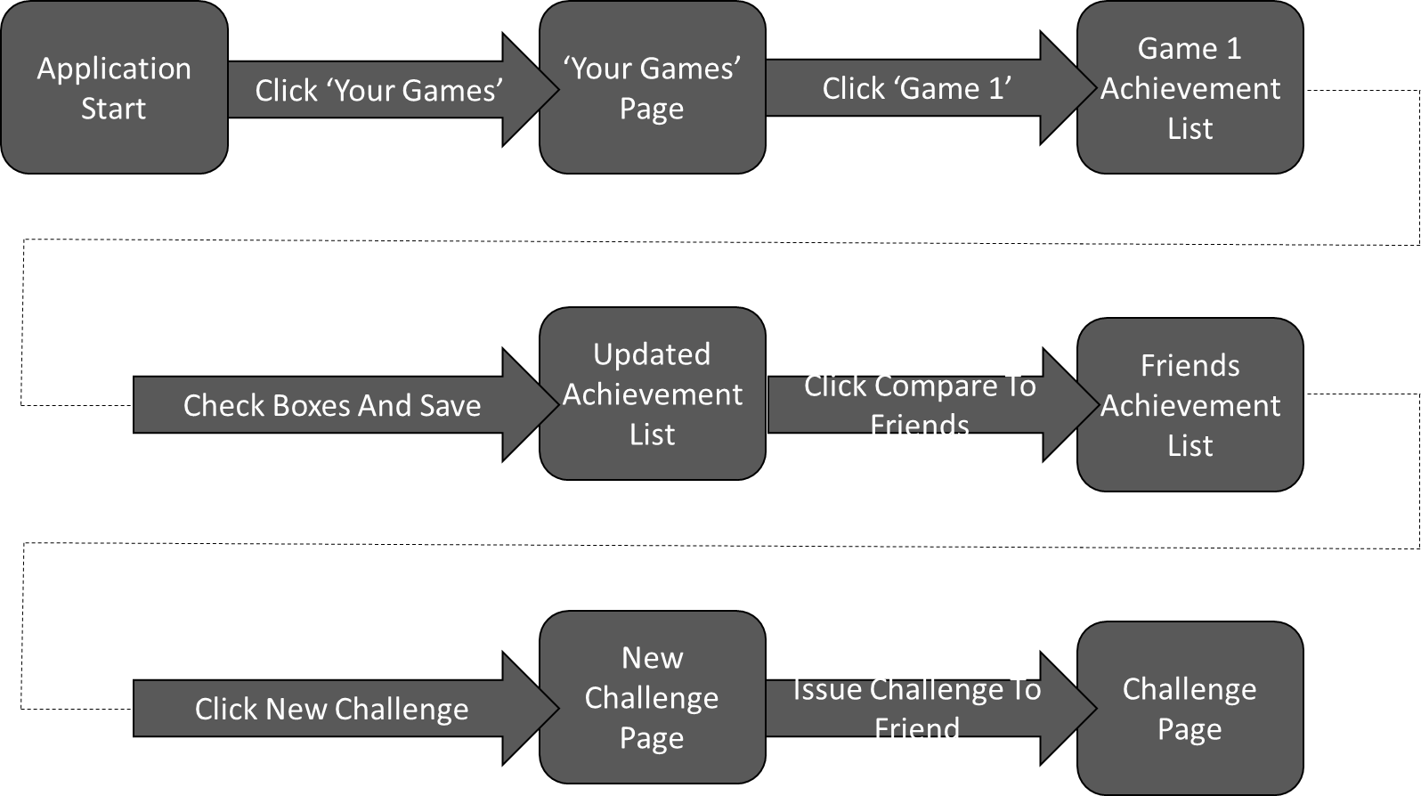

Prototyping

Basic Flow

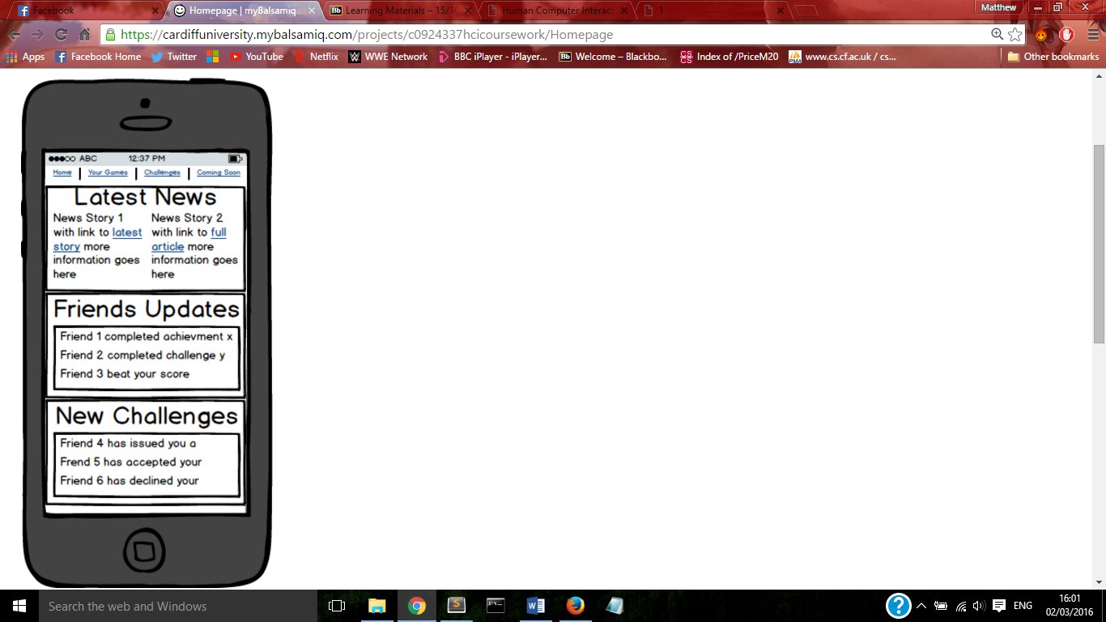

This is the application homepage, at the top is the navigation bar consisting of four clickable elements: home, your games, challenges and coming soon.

Each major heading represents the core uses of the app, each one is also a clickable link to find out more information.

This layout has been chosen to display as much relevant information to the user without cluttering the screen, and to help the user decide where to navigate from this point.

Following the use case for the basic flow from this page we will navigate to the ‘Your Games’ page from the navigation bar.

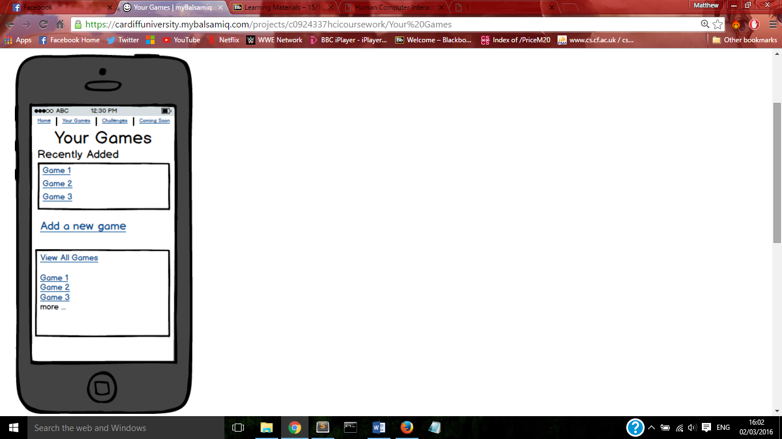

This is the ‘Your Games’ page, it features a recently added list to allow quick access to the current game you are playing.

There is a link to the ‘Add new game’ page for you to be able to add newly acquired games to your list.

At the bottom there is a window displaying a small excerpt of your available games, these can be ordered alphabetically or by recently updated, when the list becomes longer the option to view more will become available and there is the option to view all games which leads to a new page where games are searchable.

From here we will navigate to Game 1 either by clicking on it in recently added or all games.

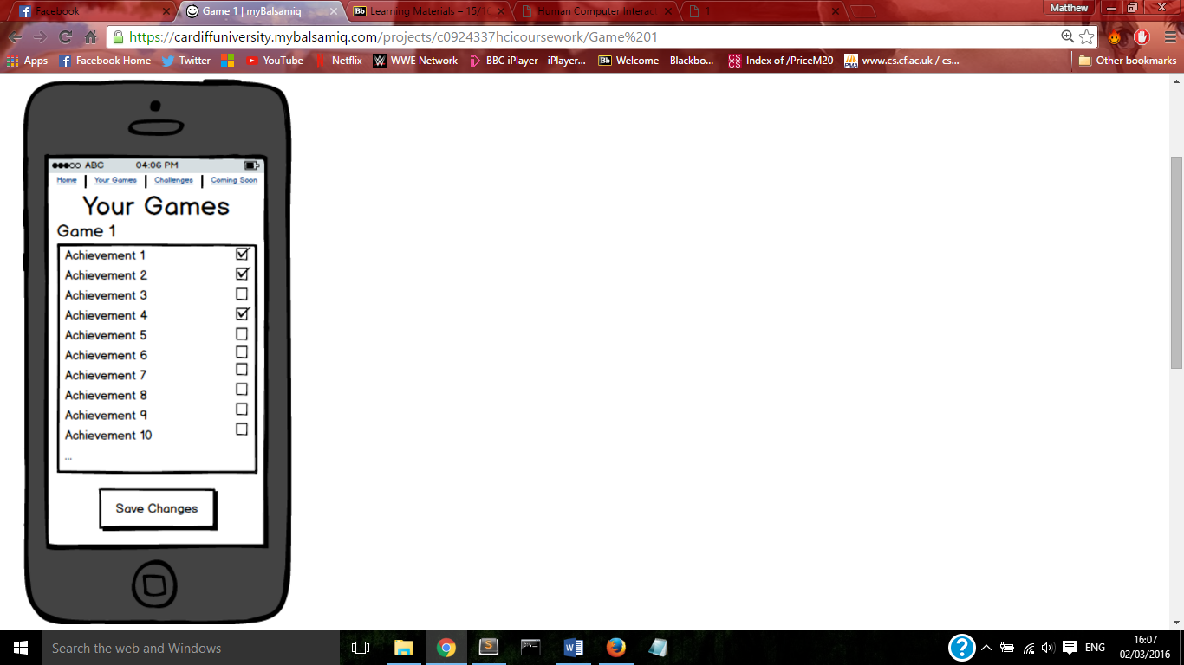

This page is the achievement list for Game 1. A scrollable list of all available achievements will be listed with checkboxes for you to update and monitor your progress.

Once all the boxes you need to update have been checked the save button must be clicked to register that achievement as completed.

Clicking the save button will navigate the user to a confirmation page

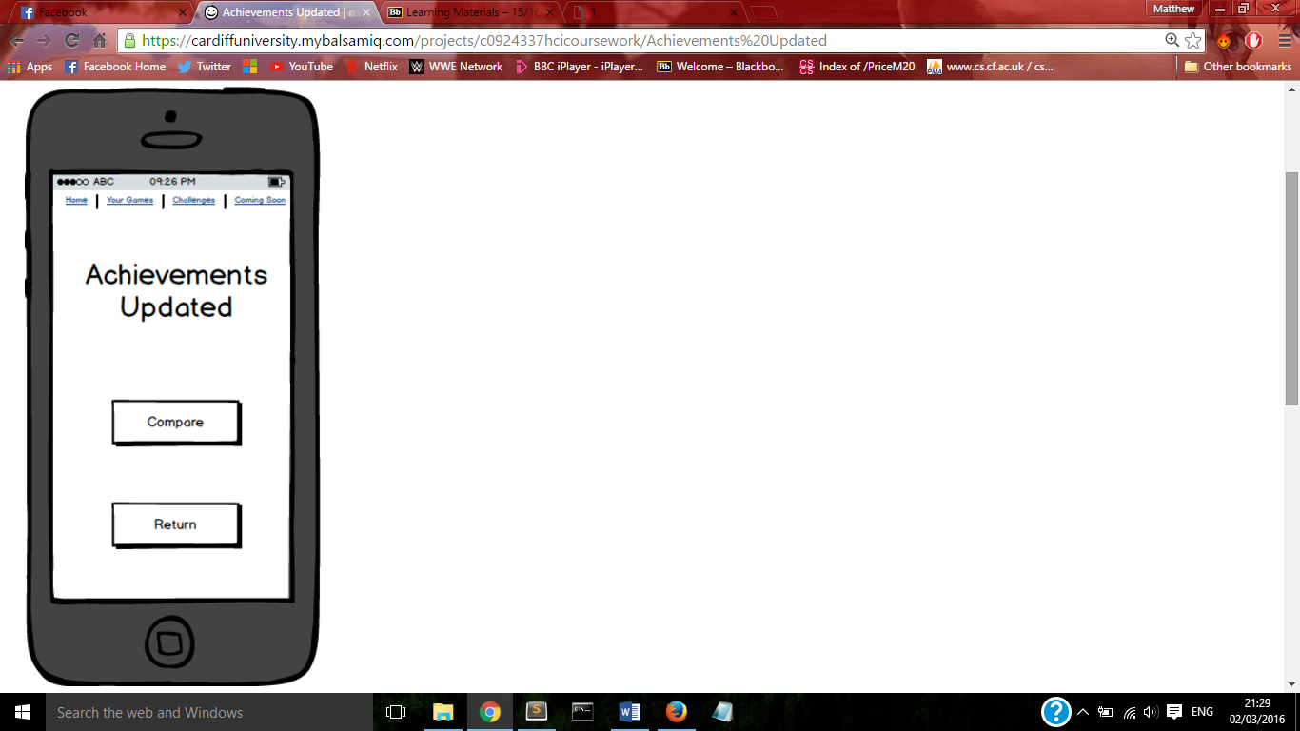

This page shows a confirmation message when your achievements have been successfully updated.

Clicking the return button will take you back to the ‘Your Games’ page or the navigation bar can be used to visit another part of the application.

This is the last step for the use case basic flow.

The design throughout the application is minimalist, giving the maximum amount of information without confusing the user.

Alternate Flow 1



For Alternate flow 1 we start at the homepage and again navigate to the ‘Your Games’ page.



This time we want to add a new game to the list, so we will navigate to the ‘add new game’ page from the link in the middle.

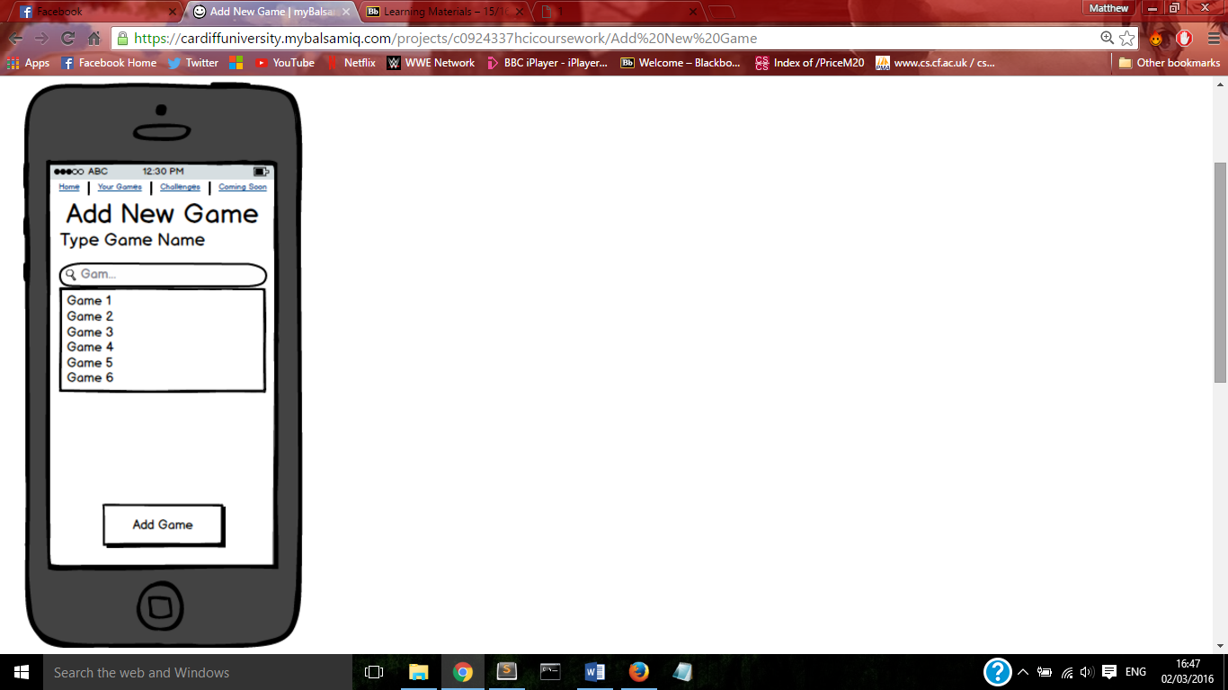

From here you type in the name of the game you wish to add and a drop down list of suggestions will be generated.

Once you find the game you are looking for click on it and click save to add this game to your list of games.

Clicking add game will also navigate to a confirmation page.

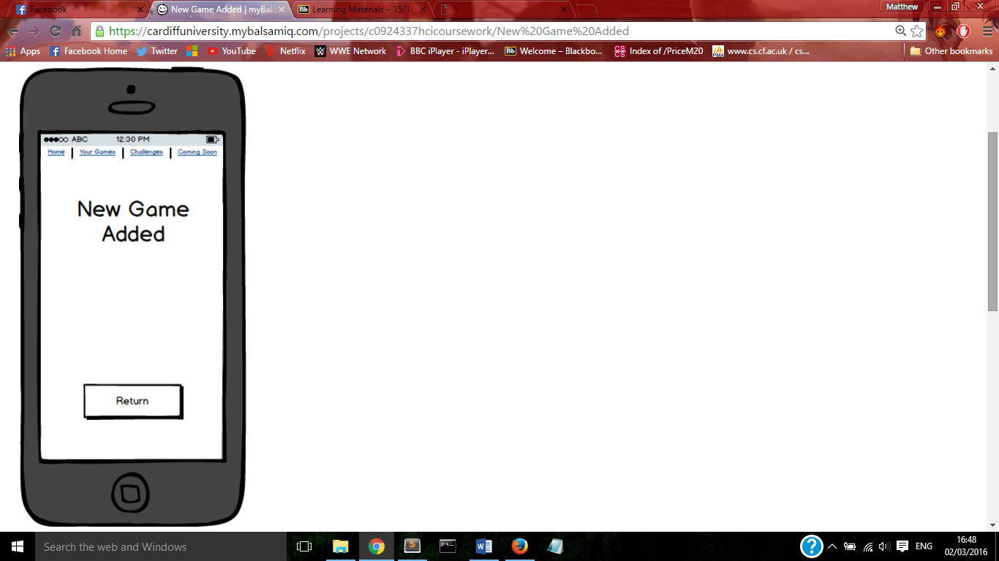

This page shows a confirmation message when your new game has been successfully added.

Clicking the return button will take you back to the ‘Your Games’ page where you can then view and update your achievements for the game you have just added.

This is the last step for the alternate flow 1.

Alternate Flow 2



This is the application homepage, the first four steps of this flow are identical to the basic flow.

Following the use case for alternate flow 2 from this page we will navigate to the ‘Your Games’ page from the navigation bar.



As before from here we will navigate to Game 1.



We will update our achievement list as before and save changes.



This time instead of returning on this page we will use the compare button to navigate to the friend’s achievements page for Game 1.

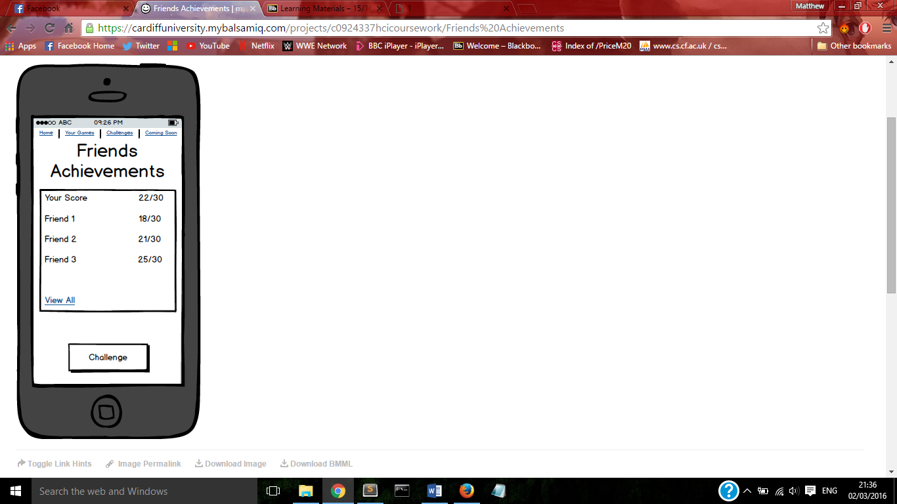

This is the friend’s achievements page where you can compare your scores against theirs. Your own score is displayed at the top and your friend’s scores are listed below for comparison.

Once you have checked out your friend’s scores you can issue them a challenge by clicking the button and navigating to the new challenge page.

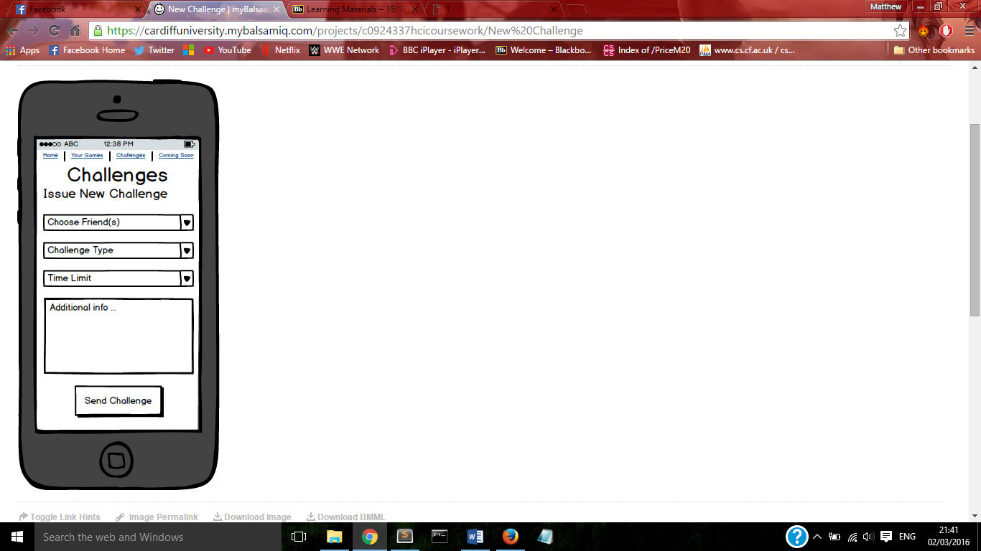

This is the new challenge page, here you select the friends that you wish to challenge, the type of challenge and the time limit for your friends to respond all via drop down lists.

You can also add a personal message to the challenge by typing in the additional info box, once you are happy with your choices click the send challenge button to send a notification of the challenge to your selected friends.

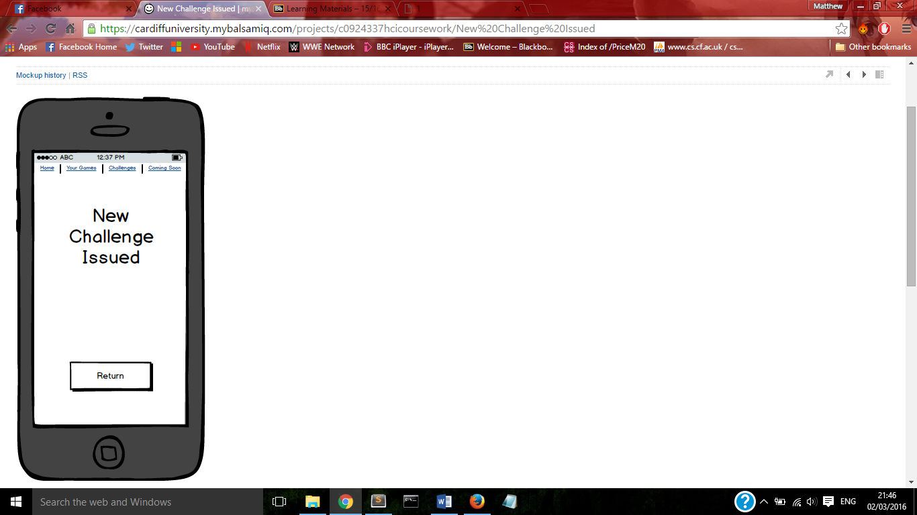

This page shows the confirmation of you challenge, from here you can return to the challenge page and wait to find out if your challenges have been accepted.

Alternative Design

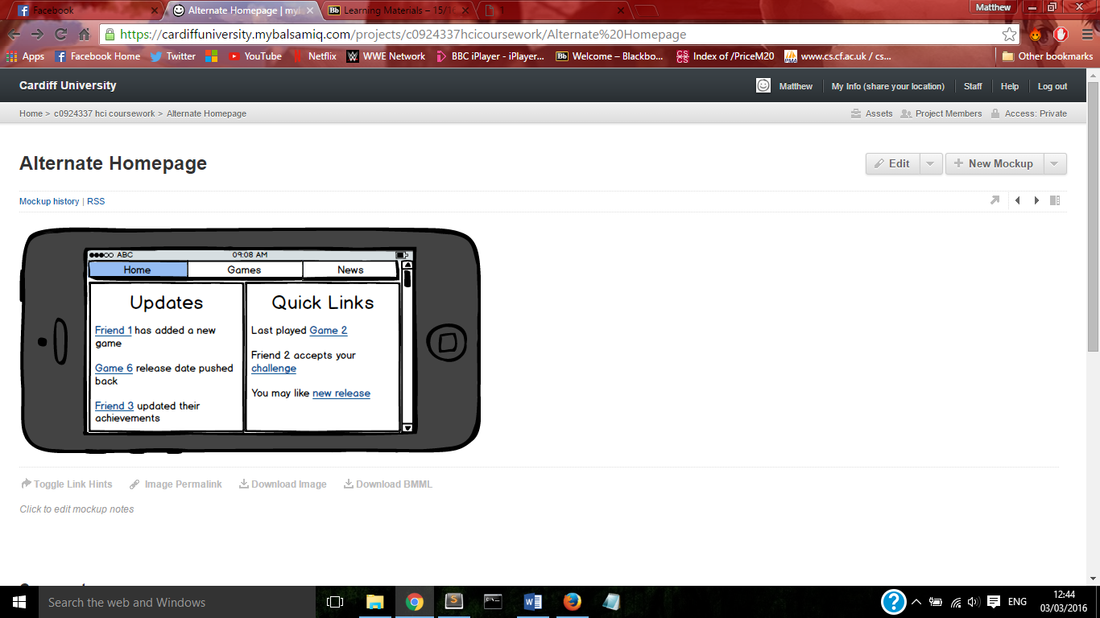

This is the alternative design homepage, the header bar is of a different style and only contains 3 headings. The screen is divided into two panels where the left shows you recent updates for both friends and news and the left shows recent updates involving the user.

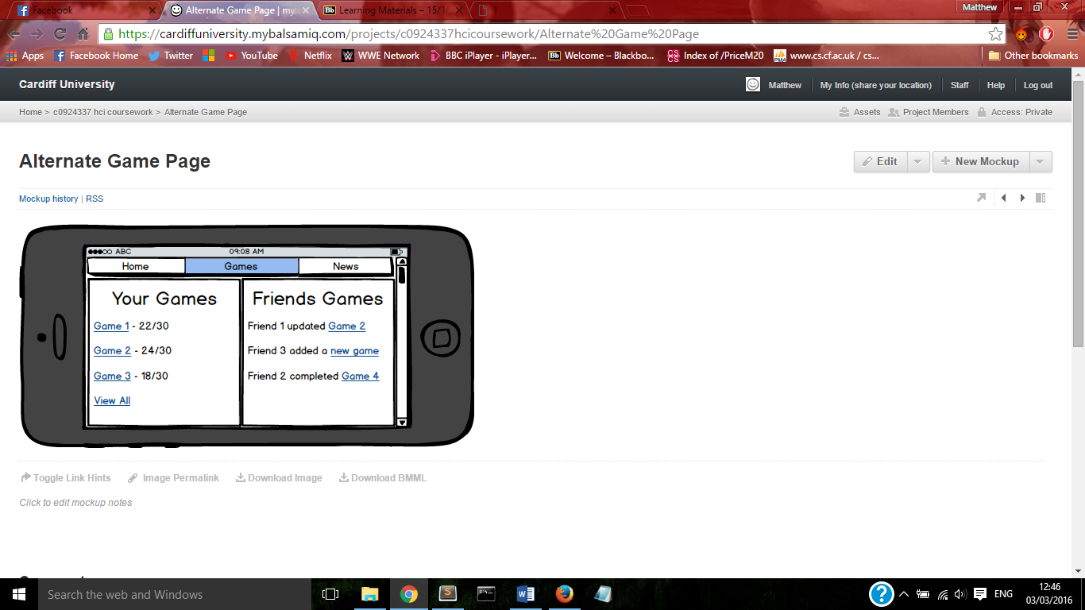

Clicking the games tab will navigate to this page. From here you can access recently updated games or view recent updates of your friends, you can click on a game to view more about it or click the view all button as we will do in this instance.

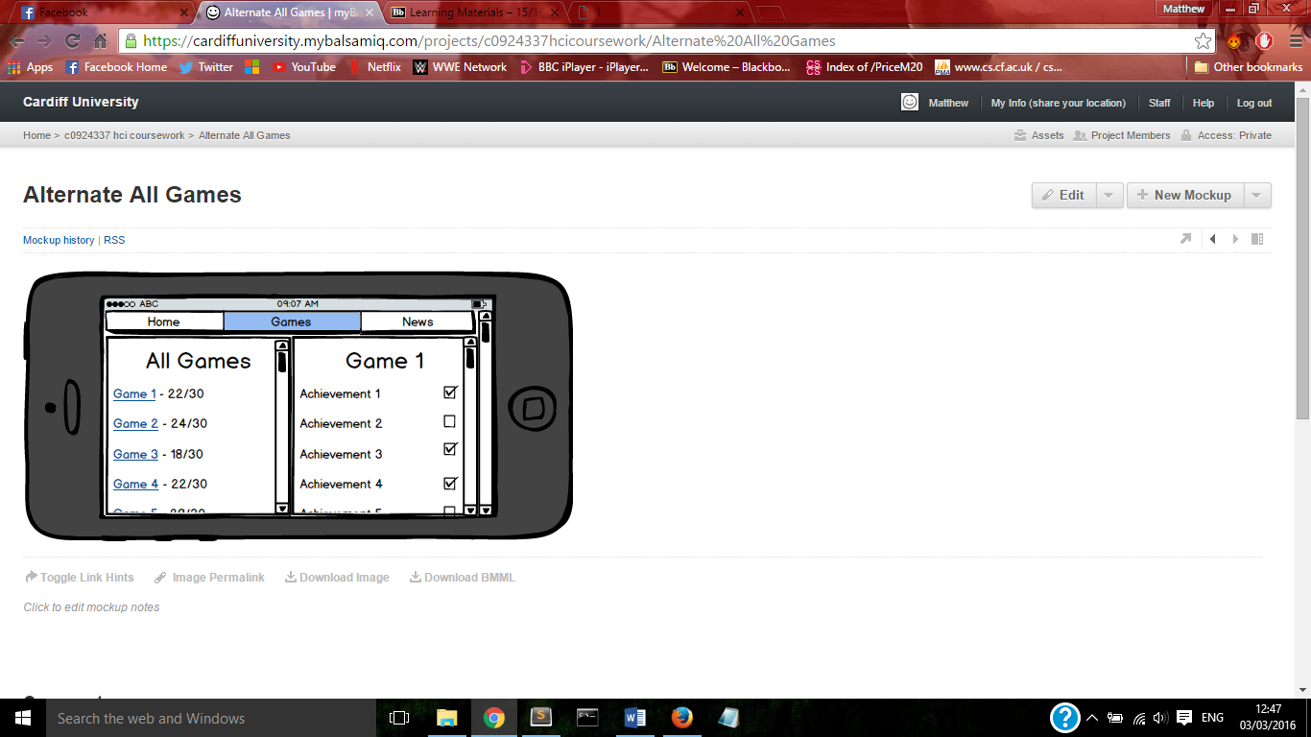

In this page the left side is a scrollable list of all your games and clicking one will cause it to show in the right side. On the right side the list of achievements can be updated as before and when scrolled to the bottom of the page you can save your updates.

My alternate design utilised the landscape orientation, in doing this I have also further simplified the layout into two columns. On most pages these columns represent one for you and one for your friends. I believe this is a better use of the space and a better layout for the intention of the app, promoting friendly rivalries and competition between you and your friends.